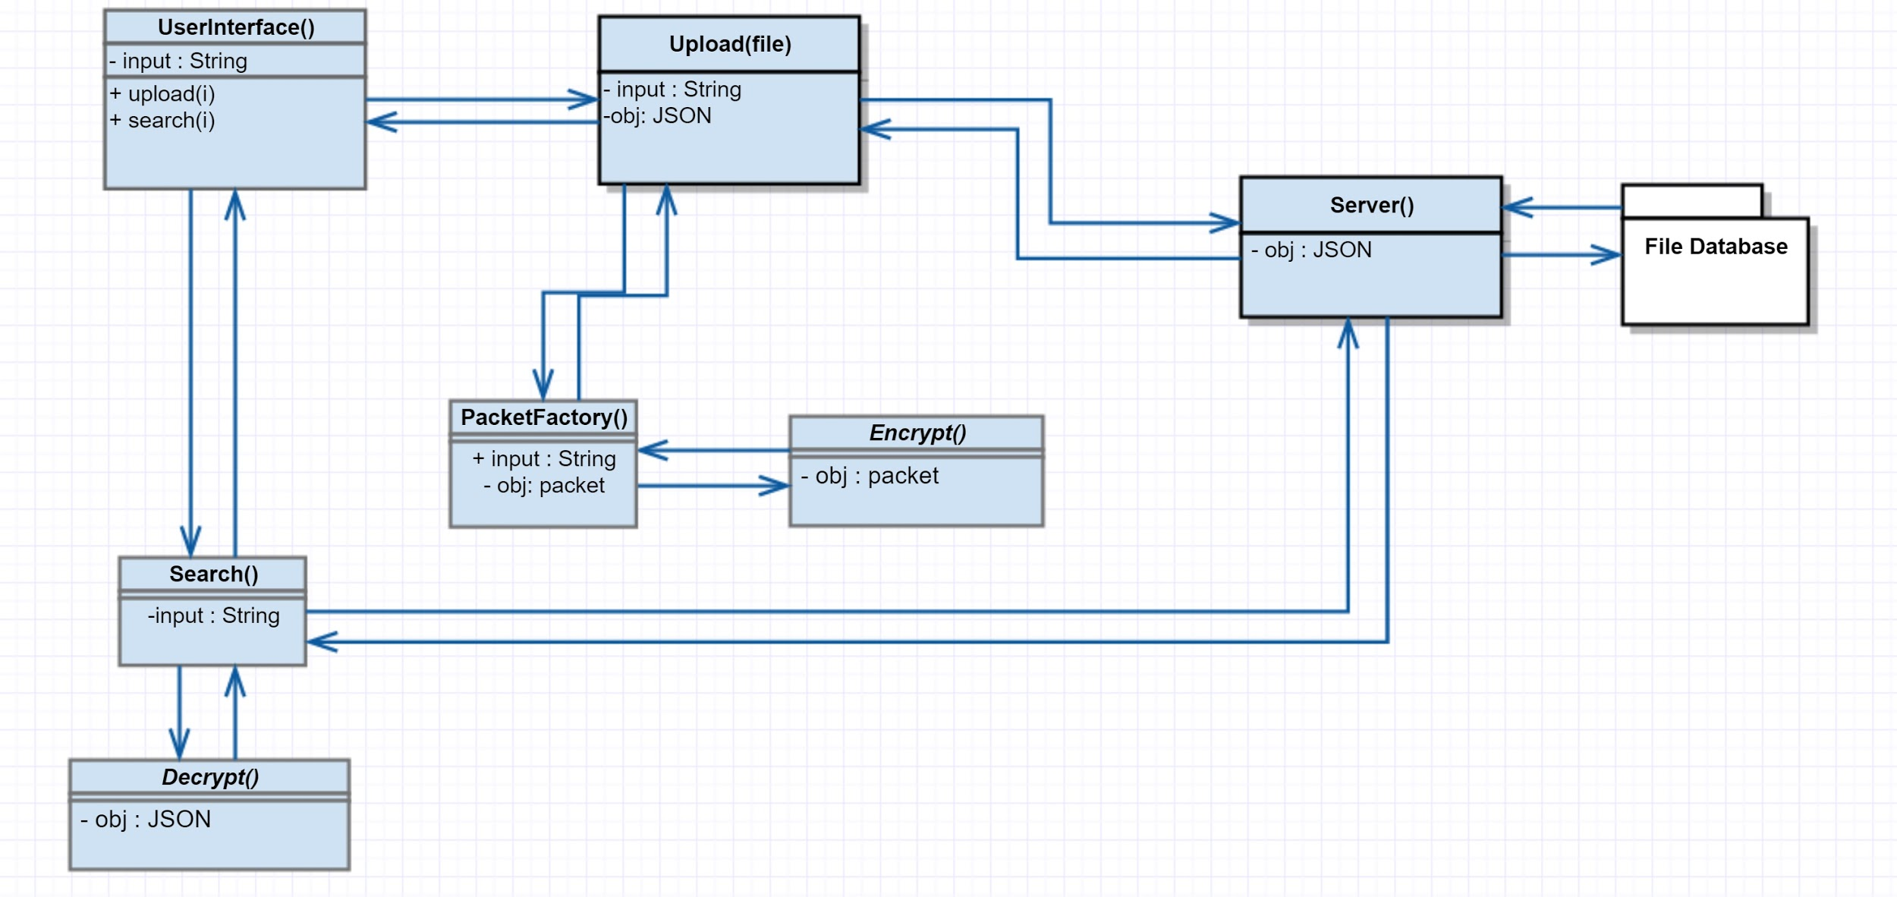
https://github.com/WCotterman/CSC376KnowledgeManagement

Below is the in progress design doc.

Rough Draft UML:

Hey guys I created a rough UML for the implementation of our knowledge base system. I know we were having trouble outlining exactly what needed to be done on thursday so here is my version of the how the processes would work together. Obviously the design document will go way more in depth but since she was looking for deliverables I am uploading my notes/diagrams so far.
- Nick

I also created a brief summary of some the functions.. everyone is welcome to edit or add:

UserInterface():
UserInterface is the interface which prompts the user to upload or search for a file.

upload():
upload takes a filename passed via user input, opens it and converts it to base64.
the base64 object is then converted to a custom packet object by passing it to the Packet Factory function.
the encrypted packet object is then converted to a JSON object and sent over TCP to the server.

packetFactory():
a new protocol packet object containing a metadata string(UniqueID, date, time, keywords, filesize, file extension, etc.) is created.
the base64 object passed through by the caller is appended to the end of the packet object.
The packet object is then encrypted by the encrypt function and returned back to the caller.

ServerClient():
the server idles waiting for our protocol packet or query string.

if the server receives a query string, the server client will query the SQL database for records
if the query receives a hit, the server will retrieve the relative base64 file from server directory via UniqueID.
the server client will then convert the base64 file to a JSON object and return it to the search client via tcp socket.

if a protocol packet is received by the server, the server client begins decryption.
the decrypted packet is then broken down and parsed.
A new entry is added to a SQLi database table.
the base64 is parsed out of the packet and a new file object is encoded.
The file is then saved as its uniqueID to a directory on the server.

Search():
Search takes a user input string and passes it to the server client and waits for a response
if query is a success wait for relative file object from server client, convert to base64, convert to original file format and save locally
else return "does not exist" and offer upload function.

Encrypt():
takes object from passed parameter
encrypts
returns encrypted object

Decrypt():
takes encrypted object from passed parameter
decrypts
returns decrypted object

File Database:
SQLi table

Data Streams:
- Please look over what I’ve written with regards to how the data is going to be transferred.
- (Protocol team recommends JSON objects because of serialization):
Example .:
import json
dict = { x:str(x) for x in range(5) }
serialized_dict = json.dumps(dict)
# Send it through the socket and on the receiving end:
dict = json.loads(the_received_string)

- Client --> Server data transmission is shaky at best right now. Not sure if we want to send 3 packets (file name, file, tags), just 2 (file, tags including file name), or 1 packet of a self designed structure.

Protocol:

- I’m going to assume she is only expecting an Application level protocol and not a transport level protocol so all transport protocol functionality will most likely be built off TCP since accuracy is what we’re looking for and I really don’t feel like reinventing the wheel.

Protocol Packet Diagram(rough draft):

- Our protocol’s packet header will likely consist of: (feel free to add/modify)
  - length
  - source
  - uniqueID
  - category
  - filetype
  - filesize
  - timestamp
- Packet payload will consist of a Base64 representation of the file being transferred

Synchronization:
- Need to find a consistent way to check on state of transaction, and transmit that back to the client / server.
- Client needs to be able to know:
  - Success/Error on commands
- Server needs to be able to know:
  - What command is coming in to initiate what command(s).

Authorization:
- I don’t have details on how you want to set up the login info. Feel free to make any changes to the document to better describe your process.

Encryption:
- Hash the password and save it.

Design Document:

General Purpose:
- A knowledge management system permits a user to create a repository of data and then use various means to search the repository.
- The user may enter text data directly into the system, as well as add both text and binary files.
- Further, the system should permit the user to organize the data by associating pieces of data with labels that represent categories or other divisions. These labels may also be considered as keywords.
- The system would permit the user to later search for relevant data and files using a variety of criteria.
System Language:
- The client and server code will both be written in Python 3.
- The server will be writing to a SQL Database.

Responsibilities of the Client:

User is given a login screen (not-GUI), requesting a username and password.
- For testing purposes, ADMIN and PASSWORD will be used as the only accepted login combination.
- Will NOT prompt the user for a port number to connect to. Port number for both the client and the server will be hardcoded (to be determined the actual number).
- If login fails 3 times, program exits.

User will be given 6 options:
- Write a new file to the database
  - Also prompt user to name the file first
  - Allow the user to type as much as they want until an empty.
  - Adding a two newline characters in a row will signify the end of the writing.
- Upload a new file to the database
  - Assumes that the file is local
  - Checks for duplicate file names in the database, and appends -copy, or a number to the end of the new file name.
- Remove a file from the database
  - Requires proper permission (authentication)
- Search for a file given any number of keywords
  - Keywords will be separated by newline characters
  - Two newline characters breaks the loop
- Open a file from the database
  - Requires the exact file name.
    - Potential issue: Two files with the exact same name in the database, will simply pull up the first one.
    - Potential fix: Append something to the end of the file name, such as a number or -copy. Make this check when uploading a file.
- Exit

Whenever a file is added to the database (either written in command line or uploaded file), the system will prompt the user to add any tags to the file. In addition, the system will automatically add several tags (listed below).
- File name
- Server time of upload
- File size
- File type
- Username
- Any tags designated by the user

Client will then attempt to transmit to the server the data (up for revision based on protocol / data streams groups).
- Sends the file name.
- Sends the content of the file.
- Sends the list of keywords.

Client will be able to process any type of file, writing to the server in binary.

Client will wait for a response from the server.
- Synchronization group: figure out how to check to make sure the client is still connected to the server during the transaction

If the client receives a response from the server (determined how by protocol):
- Writing a new file / uploading file:
  - Returns a message saying that “[file_name] has been successfully added.”
  - Returns a message saying “[file_name] was unable to be added.” on failure.
- Removing a file:
  - Returns a message saying “[file_name] has been successfully removed.” on success.
  - Returns a message saying “[file_name] was unable to be removed.” on failure.
    - Extra: server supplies information to client about why it couldn’t be removed - no file name of that type, permission, connection failure.
- Searching for a file - starting with one keyword, and working up from there:
  - Returns a message listing the file_name(s) of all files with included keywords.
  - If the list is empty, return a message “Nothing matched that criteria: [list of keyword(s)].”
- Opening a file
  - Returns a message “[file_name] will begin transferring now.” on success, and writes a new file on client’s machine, receiving the contents of the file from the server in byte form.
  - On failure, returns a message “[file_name] could not be opened.”
    - Extra: supplying the user on why - file doesn’t exist, permission

All actions will return the user to the first menu, besides exit.

Responsibilities of the Server:

The server will check to see if the user connected is authorized.
- Server will store address of connected users
- Server will remove the entry when the user disconnects

[REALLY need protocol/streams guys on this one - don’t know how you want to set up the send/receive packets. Below is my working idea.]

When the server connects with a client, the server will receive a packet, which will determine its next course of action.
- Don’t know what our heading looks like, but the working idea is that the server receives a packet containing bits to determine the action, followed by a structure in the form of [(file_file), (list_keywords)].
- Other option is that the file, and the keywords get sent separately.

[Since there are really only 4 real actions that the client is going to request from the server, I would suggest using the first or last 2 bits to determine the action. Adding a file whether it’s user inputted, or uploaded is the same action from the server’s perspective.]

Actions of the server given it receives certain requests, each request being a separate thread off of the same socket allowing for the socket to stay open but receive multiple requests:
- Adding a file (001)
  - Server will decode the file, and make any checks that it needs to, making sure that the file meets the requirements of the database’s syntax.
    - Starting list of requirements:
    - Make sure that there is a file name
    - Make sure that there is a file type
    - Make sure that there is a valid file size
  - Server will use it’s system time to add to the list of other keywords.
  - Server will add the address of the user to the list of other keywords.
  - [Server will add the authorization level of the user to the list of other keywords.]
  - Upon success, will add the file to the database, and returns a success code to the client.
    - Files will be added to the database in the form of a table - the file itself in the first field, and the
- Removing a file (010)
  - Server will decode the packet, and make sure that the request is valid.
    - Checks the authorization of the user
    - Checks to make sure there’s a file name
  - Server will search the database for a file with that file name
    - Returns an error message if no file is found with that name.
    - Returns an error message if the user isn’t authorized to access/remove that file.
  - Server will message the database to remove the file.
  - Returns a success message to the client if successfully removed.
- Searching for a file (011)
  - Server will decode the packet, and make sure that the request is valid.
    - Checks that there is a valid file name being sent.
    - Checks the authorization level of the user.
  - Server will send a request to the database, searching for a file with that name.
    - File name is stored under (list_keywords[0])
  - Check for errors
    - If no file is found, return error message saying so.
    - If a file is found, but authorization level doesn’t match, return an error message saying so. (This will be changed after testing - error message returned will say “No File” in final version.)
  - Otherwise, if a file is found and permission is granted, then returns a success message.
- Opening a file (100)
  - Server will decode the packed, and make sure that the request is valid.
    - Checks that there is a valid file name being sent.
    - Checks the authorization level of the user
  - Server will sent a request to the database, searching for a file with that name.
    - File name is stored under (list_keywords[0])
  - Check for errors
    - If no file is found, return error message saying so.
    - If a file is found, but authorization level doesn’t match, return an error message saying so. (This will be changed after testing - error message returned will say “No File” in final version.)
  - If a file is found and permission is granted, then returns a packet that starts with a success indicator, followed by the contents of the file.
    - Will not include the keywords, just the contents of the file.
  - Server will then close the file.
- Closing the socket (000)
  - Server will exit the loop.

Server will continue until it receives notice from the client that the client has finished their transaction, at which point it will close the socket.

Responsibilities of the Database

The database must be able to do the following:
- Have a method to store the data that it receives in a table.
  - Field 1 being the file
  - Field 2 being the list of keywords
- Have a method to parse through its second field given a criteria field.
  - Given a keyword, it will be able to search through each of its secondary fields lists, parse through each of those lists, and add each filename (list_keywords[0]) to a list to return.
- Have a method to remove a file from the table.
  - Looking a field 2, list_keywords[0].
  - Must be an exact match on the filename.
- Have a method to return the file to the server given a match.
  - Can use the search method detailed in point 2, but returns only the first one.
    - A cool feature would be if the server could receive a list of all files with the given name, and could ask the client which of the files they wanted to remove, and give the client the option to gather more information about each one before deciding.

Important to Note Structures

[Needs official recognition and agreement with the group.]

Packet transmission:
- One packet will be sent per transaction.
- When the server receives a packet from the client, it will run a threat of the method designated by the header.
- The server will send back a packet to the client, with a unique header to the error message or any information the client needs to receive.
  - Ex. success + filename, success + file, error + permission_error

File storage:
- Files will be stored and sent in the following structure:
  - Packet = (file, list_keywords[])
  - List_keywords[0] will ALWAYS be the file name
  - List_keywords [last] will ALWAYS be the sys_time
  - List_keywords [last-1] will ALWAYS be the username of the one who added the file

Database:
- Unless it turns out the system is far too inefficient / doesn’t work, each entry in the database will have 2 fields:
  - one to store the file itself
  - one to store the list of keywords.

Additional Features (to think about, and can be expanded)
- A way for the user to sort the data in the database
  - By user who added it
  - Alphabetically by filename
  - By file type
- A way for the user to visualize the data in the database
  - List out the file names in the order they’re found in the database

Rough Draft UML Diagram

Milestones

October 23rd:
- Functional “skeleton” code that will accept 1 client to a server.
- The client will be able to request to add a file of whatever type to the server with a file name.
  - Later will be list_keywords[0] = filename.
  - For now, will send structure (file, filename)
- The server will be able to check that there is a valid file name (not “” or “ “)
  - Will return an error if there is
  - Will attempt to add the file otherwise.
- The database will be able to inform the server that the item has been successfully added.

October 30th:
- Code will be able to accept multiple users to the same server.
- Client will be able to add, and remove files of whatever type from the sever.
- Client will be able to add any amount of keywords that they wish to the attached file.
- Client will be able to add not only typed files, but also upload their own (assuming that file is located on a local folder).
- Server will be able to check if there are the required fields for a file to be properly added and removed.
- Server will be able to add its additions to the list of keywords at the end of the keywords list.
- Database will be able to inform the server of successful and unsuccessful add and removes.

November 6th:
- Added functionality of the code, including basic (but not finalized) authorization, and encryption.
- Improved client/server communication through an agreed upon protocol for sending/receiving success and error messages, with a predetermined amount of information.
- Client and server interaction with opening, closing, and searching for files will be completed at this point.
- Database will be able to have its list of list of keywords searched through, at the very least. Will not be the most algorithmically efficient way, but will be functional.

November 13th:
- Additional efficiencies will be made to the code.
- Continued work on features, and usability.
- More finalized systems will be implemented.
- Code should be functional for multiple clients requesting multiple transactions with the same server.

November 18th:
- All features that will be added to the program will have been added.
- Last weekend before finals will be used to test code, as well as finalize any debugging.
- NO major changes will be made to the system.

November 22:
- Final exam period

